

Republic of the Philippines
Department of Education
National Capital Region
DIVISION OF QUEZON CITY SCHOOLS
Quezon City, Metro Manila

THIRD PERIODICAL TEST
MATHEMATICS IV
SY 2009 - 2010
NAME ______________________ Date ___________
Section _______________ Score___________

DIRECTIONS: Write the letter of the best answer on your answer sheet. All answers must be simplified with the correct unit. If no base is given, use base 10.
Calculator is NOT allowed.

1. Which of the following defines an exponential function?
A. f(x) = 7 – 5x C. h(x) = 3^{x}
B. g(x) = x² – 3x + 2 D. f₁(x) = x³ + 2

2. What is the y – intercept of any exponential function of the form y = b^{x}, where b>0, b 1 ?
A. – 1 B. 0 C. 1 D. 2

3. What is the range of any exponential function of the form y = b^{x}, where b > 0, b 1 ?
A. 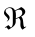 B. y > 0 C. y 0 D. y 0

4. If f(x) = 4^{2x} , what is f (  ) ?
A. 8 B. 16 C. 64 D. 128

5. Given the exponential function y = 2^{x} + 5, what is its domain ?
A. B. x > 0 C. x 0 D. x 0

6. Which of the following are the zeros of the function y = ( x − 5 )( x – 4 ) ?
A. B. C. D.

7. What is the value of g (−2 ), if g(x) = 25x – x ² .
A. – 46 B. 46 C. 54 D. – 54

8. The graphs of y = 5^{x} and y = 5 ^{– x} are reflections of each other with respect to the line
A. y = 0 B. x = 0 C. y = 5 D. x = 5

9. What is the line of asymptote of the function y = 3^{x} − 2 ?
A. y = 0 B. x = 0 C. x = −2 D. y = −2

10. Which one has a graph same as that of y = 2^{x} but all points of which are moved 4 units above
the given graph ?
A. y = 2^{x} + 4 C. y = 2 ^{x} – 4
B. y = 2 ^{– x} – 4 D. y = 2 ^{– x} + 4

11. Find the inverse of the function f(x) = 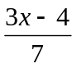.
A. 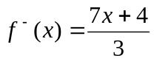 C. 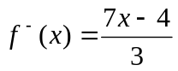
B. 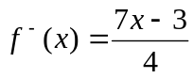 D. 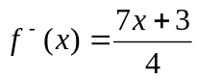

12. What is the line of symmetry of the graph of the quadratic function y = 3x² – 3 x – 10 ?
A. x = B. x =  C. x = D. x =

13. Which of the following equations serves as the mirror if the inverse of a relation is obtained?
A. y = –x B. y = 2x C. y = x D. y = ½ x

14. If If x + 2 is a factor of x² – 5x – 2k, what is the value of k?
A. 7 B. -7 C. 14 D. 14

15. What must be the numerical coefficient of x in 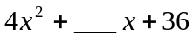 to make it a perfect square
trinomial ?
A. 8 B. 12 C. 20 D. 24

16. Which of the following functions is NOT exponential ?
A. 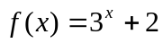 C. g(x)= ( – 4 )^{2x}
B. 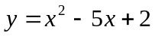 D. 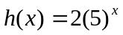

17. What is the product of 2⁵ and 5² ?
A. 480 B. 720 C. 800 D. 844

18. What is the value of x in 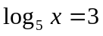?
A. 125 B. 15 C. 8 D. 5

19. Given the exponential equation 4³ = 64, which one is its logarithmic form?

A. 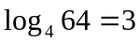 C. 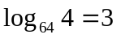
B. 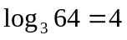 D. 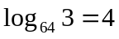
20. What value/s of x is/are not included in the domain of the function f(x) = 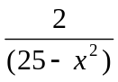?
A. { 5 } B. { 5 } C. { 5 } D. { 5, 5 }

21. If log 2 = 0.3010 and log 3 = 0.4771, what is the value of log 18?
A. 0.7781 B. 1.2552 C. 1.4313 D. 0.6990

22. When written in single logarithmic form, which expression is equivalent to log x + 2log y – 3log z?
A. log 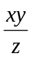 B. log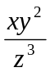 C. log 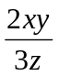 D. log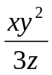

23. Solve for x in log( x – 4 ) + log( x – 2 ) = log(2x – 7 ).
A. −5 and 3 B. −3 and 5 C. 3 and 5 D. 4 and 5

24. What binomial of lowest degree must be multiplied to 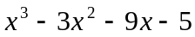 to make it a polynomial
with perfect root?
A. x+5 B. x – 5 C. x – 1 D. x + 1

25. What is the remainder when the polynomial (x³ – 4x²+ 5x – 7) is divided by ( x – 1) ?.
A. 9 B. -9 C. – 5 D. 5

26. What is the range of the relation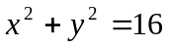?
A. 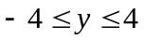 B. 0 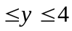 C. D. 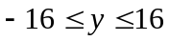
27. What kind of real numbers are { 0, , 2, , 3} ?
A. coterminal B. rational C. ordinate D. quadrantal

28. What are the coordinates of P( 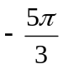 ) ?
A. (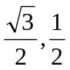) B. (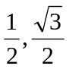) C. (–) D. (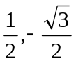)
29. If the unit circle is divided into 24 equal parts, what is the length of one of the equal parts?
A. B. C. 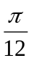 D. 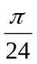
30. Given point P( x, y ) on the unit circle, what function does stand for ?
A. sine B. cosine C. tangent D. cotangent

31. What is the value of sine 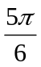 ?
A. B.  C. – D. 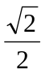

32. Which of the following is a coterminal angle of 40?
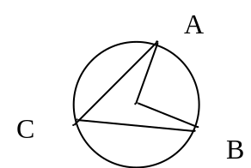
A. 360 B. 365 C. – 180 D. 400

33. In the given figure, if O is the center of the circle and C is a point on
circle O, what is the measure of 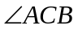 if 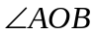 measures 80?

A. 80 B. 60 C. 50 D. 40

34. What is the inverse of any exponential function?
A. circular function C. polynomial function
B. quadratic function D. logarithmic function

35. What is the domain of log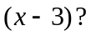
A. x 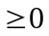 B. x > 0 C. x 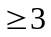 D. x > 3

36. What is the reference angle of 300?
A. 30 B. 45 C. 60 D. 90

37. What is the inverse of the quadratic function f(x) = 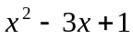?
A. 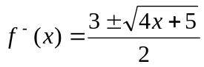 C. 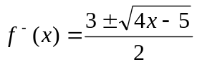
B. 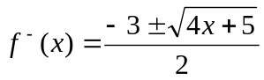 D. 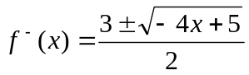

38. Find the equation of a circle in standard form with center at (– 1, 2) and passing through P( 0, 4 ).
A. 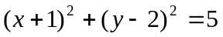 C. 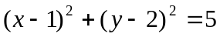
B. 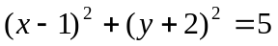 D. 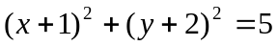

39. A central angle of – 225 is equivalent to how many radians?
A. 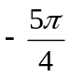 B. 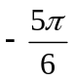 C. 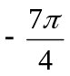 D. 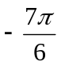
40. The sides of a rectangular field are of lengths 3x meters and 2x meters. What is the perimeter of
the field in meters?
A. 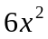 B. 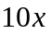 C. 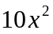 D. 5x

41. The point ( 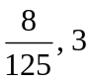 )belongs to 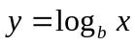. Find b.
A. B. 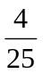 C. 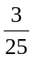 D. 

42. How much would Php15,000.00 amount to in 5 years at 4% compounded annually?
A. Php 17 500.00 C. Php 20 120.5
B. Php 18 249.79 D. Php 18 349.15

43. The diagonals of a rectangle are 30 centimeters long and intersect at an angle of 60. Find the
length of the rectangle.
A. 10 cm B. 15 cm C. 15 cm D. 10 cm

44. Simplify : 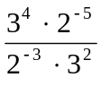
A. 24 B. 18 C. 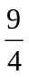 D. 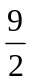

45. In which quadrant is the terminal point of an arc of length 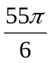 ?
A. Q IV B. Q III C. Q II D. Q I

46. What is the simplest form of the trigonometric expression 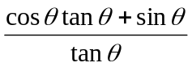 ?
A. 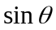 B. 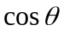 C. 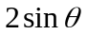 D. 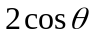

47. What is the value of f(x) if x = 2, and f(x) = 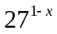?
A. 27 B. – 27 C. 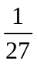 D. 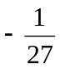

48. A certain kind of bacteria divides into two after 2 hours if given enough food. If originally there
are 4 such organisms in a container, how many would there be after 4 hours?
A. 8 B.12 C. 16 D. 20

For numbers 49-50, refer to the given problem:

An airplane at a fixed altitude flies towards an airfield. At one point, the angle of depression
of the airfield is 30. After flying 3 km more, the angle of depression is 60.

49. What function is needed to solve for the altitude of the plane?
A. sine B. cosine C. tangent D. csc

50. What is the altitude of the plane?
A. 1.5 km B. 3km C. 3 km D. 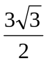km

